Assignment 7 (Week 7)
- Place symbols of 3 required RF Modules and all relevant components, including a voltage regulator U12 to feed Wi-Fi Module, - on page 4. Assign footprints to all of them. Copy everything from sheet 10 of IoT Kit into your page 6.
Done, please see the attached KiCad project folder
- Check that all components have appropriate footprints in their properties (menu:Tools → Edit Symbol Fields). Without them it is impossible to design and create a PCB.
Done, please see the attached KiCad project folder
- Solder 8-pin connector to the FRAM PCBA. Connect FRAM PCBA to STM32L475 PCBA using jumper wires. Submit a picture showing physical connection of the PCBAs.
IoT board | FRAM Module MB85RS64V
CN1 - PA5 - SPI1_SCK (D13 on the board) | SCK
CN1-PA6 - SPI1_MISO (D12 on the board) | MISO
CN1 - PA7 - SPI1_MOSI (D11 on the board) | MOSI
CN3 - PA4 - SPI1_NSS (D7 on the board) | CS
CN2 – 3.3V | VCC
CN2 - GND | GND
3.3V of the STM IoT board | NWP
unconnected | NHOLD
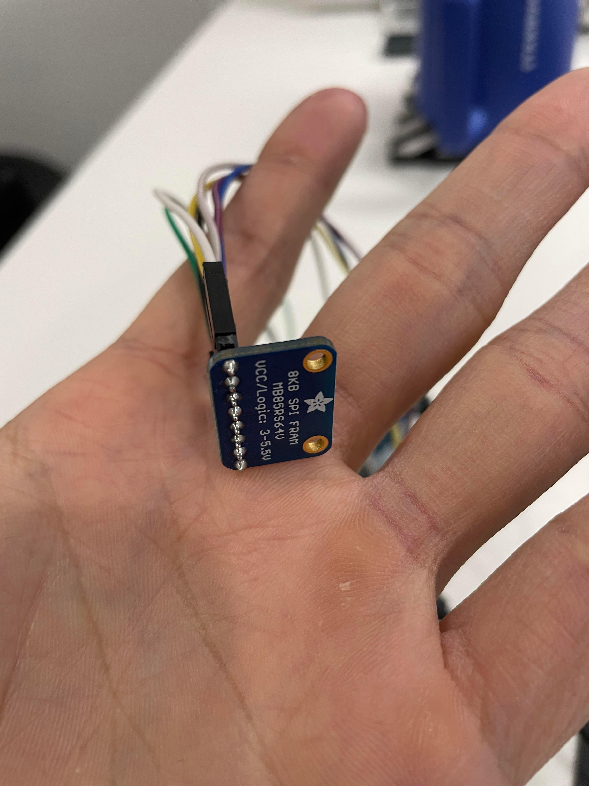
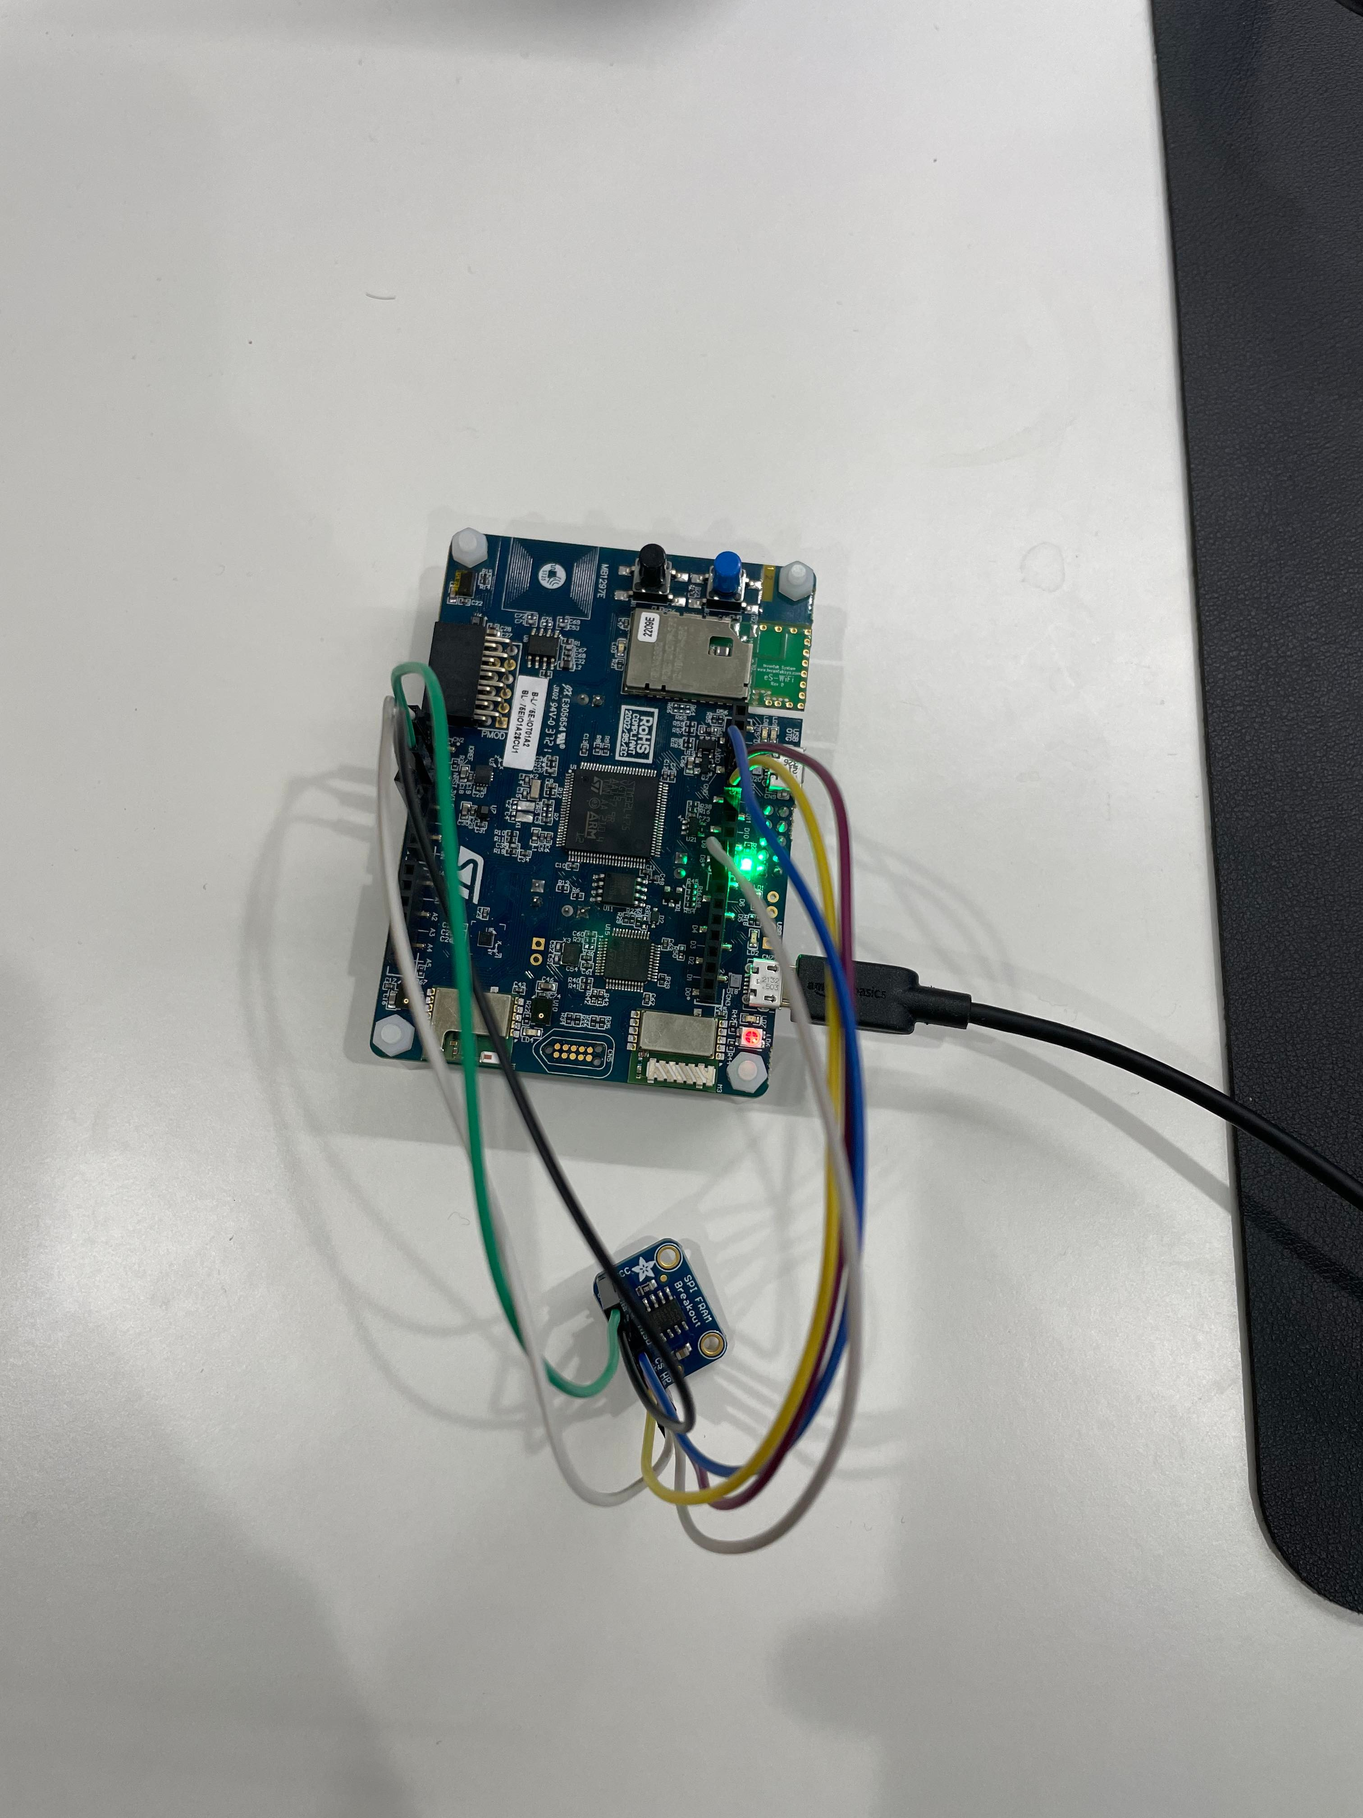

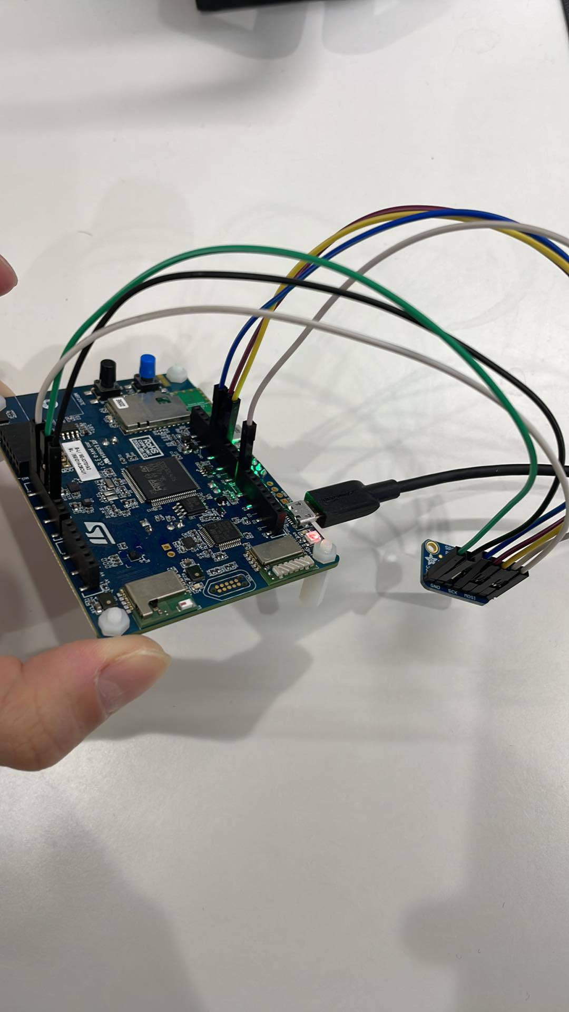
- On sheet 10 of the IoT Board, there is LED2, fed through resistor 330 Ohm. Calculate the current going through LED (and supplied by uC).
I = V / R = 3.3 / 330 = 0.01 (A)
- On sheet 10 of the IoT Board find User’s Pushbutton: calculate voltage value on the input EXTI13 of the microcontroller at 300us after closing B2.
When the push button is closed for 300 us, we can assume that the button debouncing is over, the current is dominated by the branch 3.3V to GND, so the voltage value to the microcontroller is near 0V.

